New Bank Reconciliation Questions

- How do you add a new Checking Account?
- Bank Account Group: This tab is used to manage bank account group codes that are used for bank reconciliation. Each bank account group has fund codes and fund years associated with that group.
Bank Reconciliation > Tables > Bank Account Fund Groups > Bank Account Group tab

Click +Add
- Code: Type the four-character code for the bank account group.
- Description: Type the bank account group description.
- Bank Account Nbr: Type the account number for the bank account group.
- Inactive: Select to exclude the group code from being displayed and used throughout the system.
- Extract HR: Select to include payroll checks and deduction/transfer checks if paid from the payroll check stock in the bank account fund group. This field can be selected for one bank account group.
- Include Auto JV’s: Select to include the automatically created journal voucher from the payroll and vendor check processing.
- SAVE
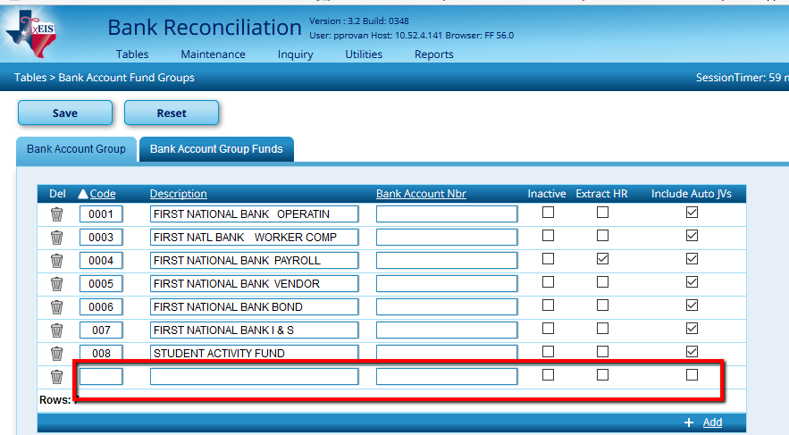

- Bank Account Group Funds
Bank Reconciliation > Tables > Bank Account Fund Groups > Bank account Group Funds Tab
This is used to create multiple group funds for each bank account;
- Group Code: Click to select a bank account group code from the list. All fund codes and years that exist for the group code are displayed.
- Click the +Add
- Enter the Fund, Fscl Yr, Obj, Sobj, Investment Type & Investment Description.

- Should I check the box in my tables to include auto JVs?
Auto JV’s can be helpful in some situations, and confusing in others. In general, we recommend including auto JVs for clearing accounts only. Here are some things to consider:
- If you have a Clearing account at the bank, you transfer money from your Local Maintenance or General Operating account to this account each time you run Payroll or cut Accounts Payable checks. This means you will see a transfer on your bank statements. By including the auto JVs in the Bank Reconciliation in TxEIS, you will have a corresponding Journal Voucher listed that you can check off. This will make your reports match your statements more accurately than in the past.

- If however, you do not transfer money between accounts at the bank, these Journal Vouchers will simply be confusing and will not tie to anything on your bank statements.

- If you choose to include auto JVs, you must check the boxes to clear those applicable to the bank reconciliation to affect the system cash appropriately. Not choosing to display those means that TxEIS will assume they occurred and you will have the same result we had in the “old” bank rec system.

- Do you have to go back and start over once you make changes? If you correct a JV do you have to start over and recheck all your cleared items again?
No…. you will make your correction and then you can Import/Execute the file again.
Go to Maintenance > Bank Transactions > Create Transactions and Execute again.
It will keep any items that you have checked showing they have cleared.
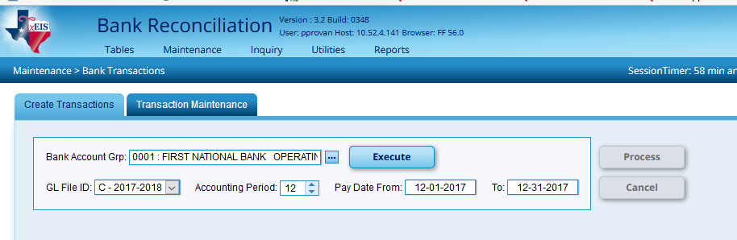
Example: If you need to add a Cash Receipt and you have already checked several cleared receipts on the Bank Rec and you do not want to lose these items that you checked, you can go into Finance, enter your Cash Receipt then go back to Maint > Bank Transactions > Create Transactions – execute the bank account again. It will keep all the Cleared items you have checked.

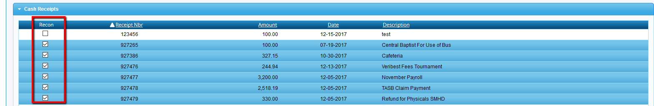

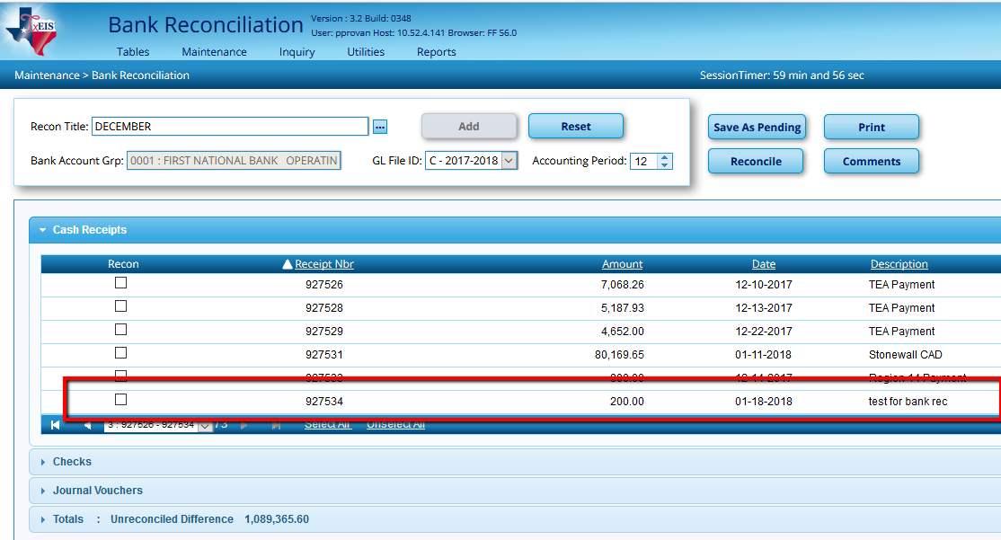
When you Extract again it will not double amounts and will only pull over the new items.
This will show checks entered and checks voided.
JV numbers description will group the days JVs under one date.
Vendor EFT will now start showing. It will show month, day, year and description. EFT payments are extracted as a JV with the following JV Number. (description for all is EFT Total). Unfortunately, they will be grouped together by date and you will not be able to see the difference in the EFT under that vendor.
Payroll EFT will show Month, Date and Year. It will be one total and will be grouped together by date.

- How do I go back and print a Reconciliation from previous months that are already Reconciled?

If it has been Reconciled the report will not be listed here until you click on Reconciled and then Search.

You will receive a list of all your Bank Reconciliation so you can look at last months or last years.
Click on the Recon Title.

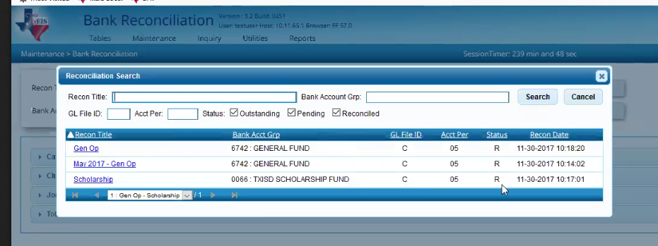

On the screen this will only show you the items that were reconciled and the totals. It will not show you the individual items of Cash Receipts, Checks or JV’s. It will not show you every transaction that was listed during the process of the Bank Reconciliation but it will show you which items were reconciled.

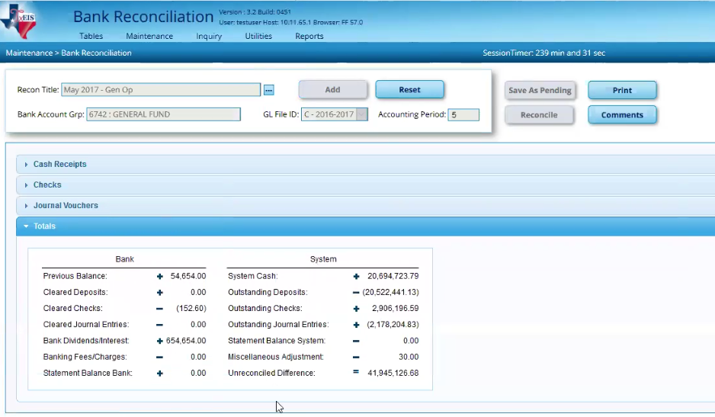

Once you click on Print you will be able to see all the reports. It will give you all the transactions at that particular reconciliation including the outstanding items and the items that cleared along with the totals.

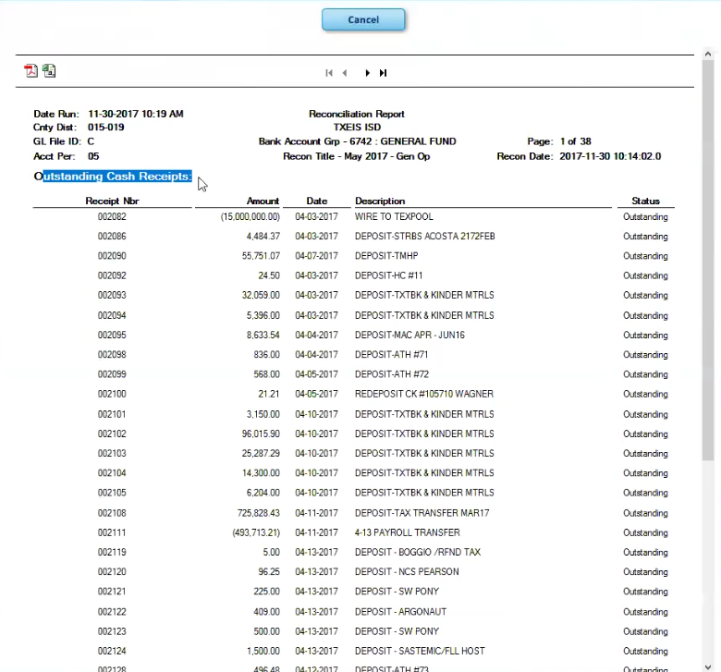

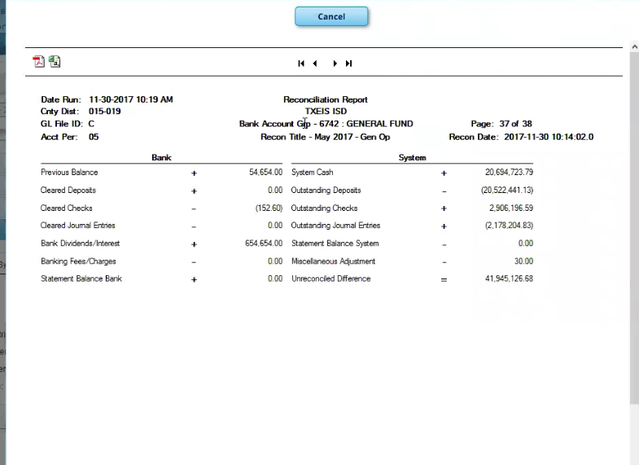

- How can I retrieve bank transactions from prior months?
By putting in a date range ex: 04/01/2017 to 04/15/2017 you will see the cash receipts, check inquiry and JV for that period.

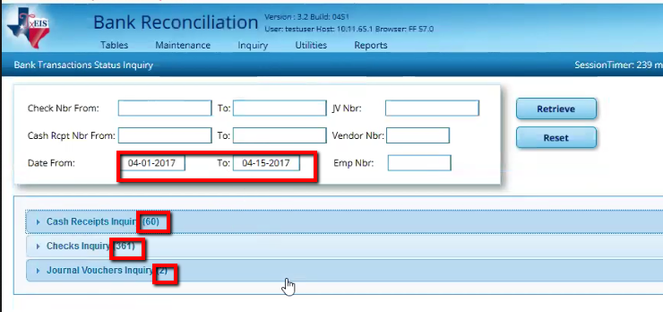

- Do you need to put the Bank Statement Balance in twice?
Yes – It will not balance on the right side – the System side – if you Inactivate the Bank Statement Balance on that side. It will show the system balance in the Unreconciled Difference. This screen shot shows what would happen if you did not have the Bank Statement Balance listed under the System side
Note: TxEIS defaults to naming this field Statement Balance Bank System.

You cannot name it the same as the Statement Balance Bank since it’s already being used, but can choose to re-name Bank Statement Balance as we’ve recommended.

I put inactive for the Statement Balance System (This is incorrect – this is showing you an example of what would happen)

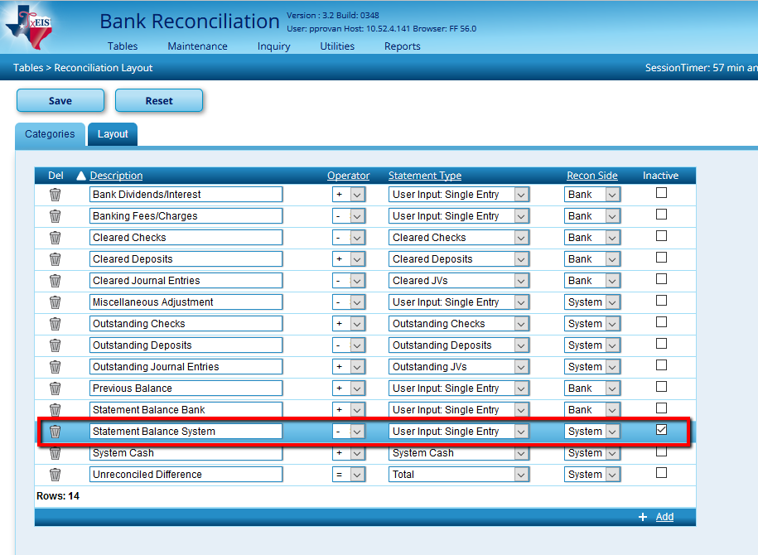

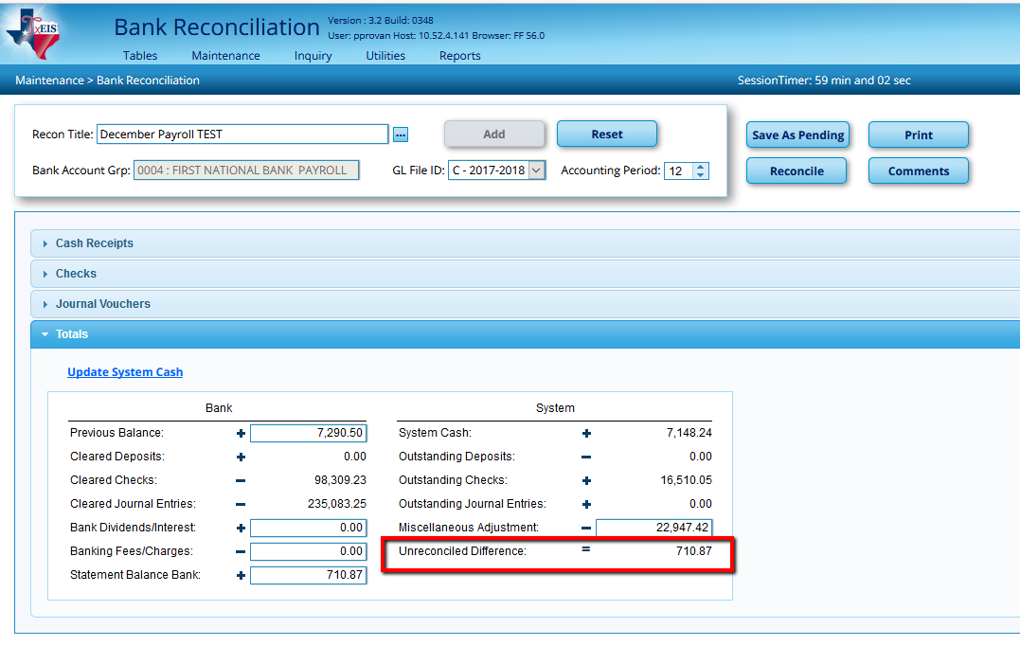

- What happens if I forget and have the Single column instead of the Double Column Layout?

The system will total all the amounts in that column instead of reconciling like you normally would. Be sure to select the double column in Bank Reconciliation > Tables > Reconciliation Layout > Layout.

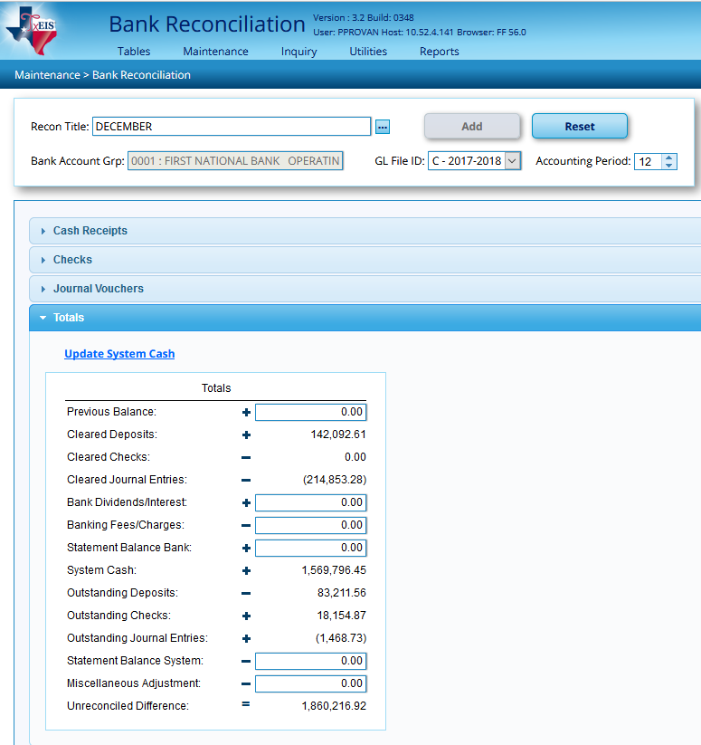
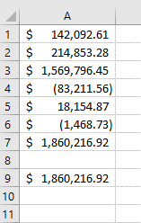

- Is there an Export / Import in the Bank Reconciliation?
No, there is not an export/import process for Bank Rec. The transactions always show in the reconciliation provided they have not been reconciled. Once you save as pending, it is only the layout that does not change.

- At what point can I go back and change the Layout to double column from the single column or make any other changes to the Tables?
It’s after you Create the Transactions and before you enter the Recon Title on the Maint > Bank Reconciliation. For safe practices, we recommend it’s best to first verify your tables when you start on your Bank Rec. - Bank Reconciliation > Tables > Reconciliation Layout > Layout tab - Be sure and verify it is double column.

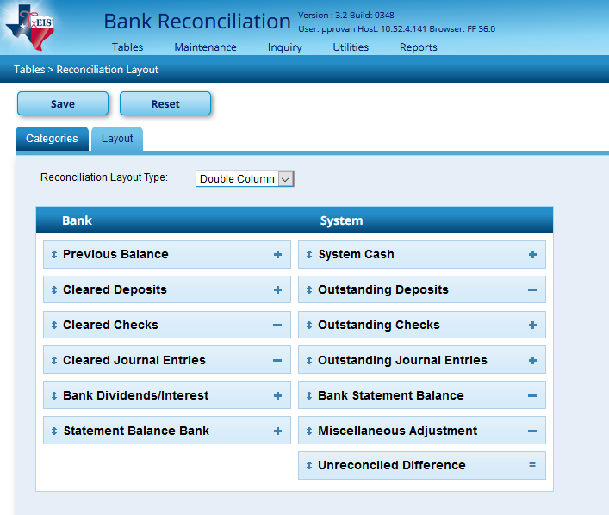

- How can I look at previous Bank Recon prior to the New Bank Recon Application?
You are unable to look at previous Bank Reconciliations prior to the New Bank Recon Application. Once you have created the Bank Rec in the new Application then you will be able to go back to the time you started working in this application and pull those Reconciliations.

- I’m having problems with my Journal Vouchers not showing a negative amount. An example would be for my EFT Totals.
Region 20 is aware and is working on this problem. A work around would be to go to Bank Rec > Maintenance > Bank Transactions > Transaction Maintenance and change the amount to a negative by clicking on the amount and putting a minus in front of the number. It will put parenthesis showing a negative. This will not affect the System Cash totals.

